Ticket Booking System

# Database Tables:

## Tasks 1: Database Design:

### Create Database named "TicketBookingSystem":

CREATE DATABASE TicketBookingSystem;

##### Results:

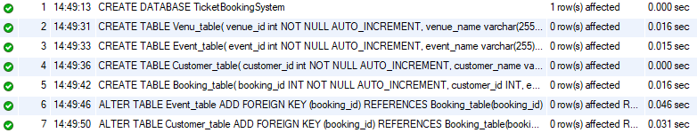

### Write SQL scripts to create the mentioned tables with appropriate data types, constraints, and relationships:

#### • Venu:

CREATE TABLE Venu_table(

venue_id int NOT NULL AUTO_INCREMENT,

venue_name varchar(255),

address varchar(255),

UNIQUE(venue_id),

PRIMARY KEY (venue_id)

);

##### Results:



#### • Event:

CREATE TABLE Event_table(

event_id int NOT NULL AUTO_INCREMENT,

event_name varchar(255),

event_date DATE NOT NULL,

event_time TIME NOT NULL,

venue_id int,

total_seats int NOT NULL,

available_seats int NOT NULL,

ticket_price DECIMAL(10,2),

event_type varchar(7),

CHECK (event_type IN ('Movie', 'Sports', 'Concert')),

booking_id int,

PRIMARY KEY (event_id),

FOREIGN KEY (venue_id) REFERENCES Venu_table(venue_id)

);

##### Results:



#### • Customers:

CREATE TABLE Customer_table(

customer_id int NOT NULL AUTO_INCREMENT,

customer_name varchar(255),

email varchar(255),

phone_number bigint,

booking_id int,

PRIMARY KEY (customer_id)

);

##### Results:



#### • Booking:

CREATE TABLE Booking_table(

booking_id INT NOT NULL AUTO_INCREMENT,

customer_id INT,

event_id INT,

num_tickets INT DEFAULT 1 ,

total_cost DECIMAL(10,2),

booking_date DATE NOT NULL,

UNIQUE(booking_id),

PRIMARY KEY (booking_id),

FOREIGN KEY (customer_id) REFERENCES Customer_table(customer_id),

FOREIGN KEY (event_id) REFERENCES Event_table(event_id)

);

##### Results:



### Create an ERD (Entity Relationship Diagram) for the database:

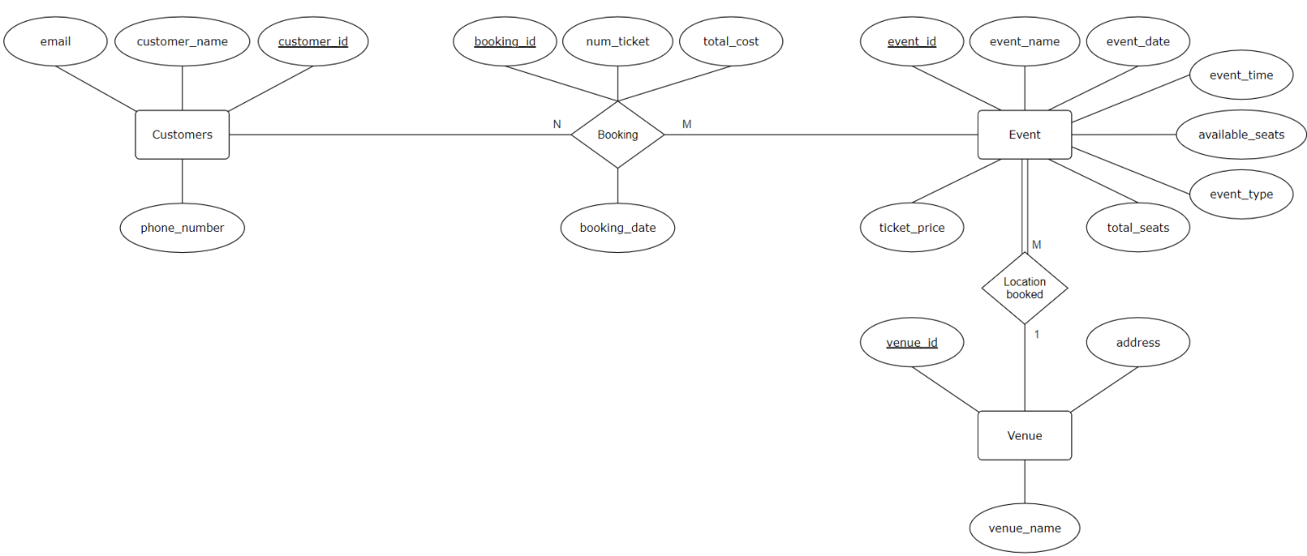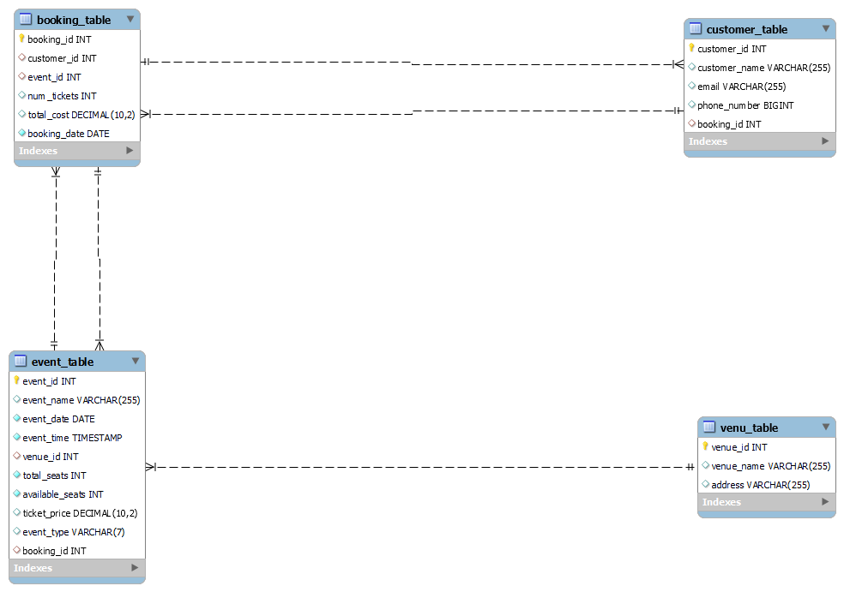

### Create appropriate Primary Key and Foreign Key constraints for referential integrity:

ALTER TABLE Event_table

ADD FOREIGN KEY (booking_id) REFERENCES Booking_table(booking_id);

ALTER TABLE Customer_table

ADD FOREIGN KEY (booking_id) REFERENCES Booking_table(booking_id);

##### Results:



## Tasks 2: Select, Where, Between, AND, LIKE:

### Write a SQL query to insert at least 10 sample records into each table:

INSERT INTO Venu_table (venue_name, address) VALUES

('EGA Theatre', 'Kilpauk'),

('Chepauk Stadium', 'Chepauk'),

('MGR Theatre', 'Vadapalani'),

('Sathyam Cinemas', 'Royapeta'),

('ECR Beach', 'ECR'),

('Sangam Cinemas', 'Pachiyapaas'),

('Mayajaal Multiplex', 'ECR'),

('PVR', 'Anna Nagar'),

('AGS', 'OMR Navalur'),

('S2', 'Perambur');

INSERT INTO Event_table (event_name, event_date, event_time, venue_id, total_seats, available_seats, ticket_price, event_type) VALUES

('Avengers: Endgame', '2019-04-26', '09:30:00', 1, 100, 50, 1500, 'Movie'),

('IPL Cup Final', '2024-05-26', '19:30:00', 2, 15000, 10000, 2000, 'Sports'),

('A.R. Rahman Special', '2023-09-10', '18:00:00', 3, 30000, 0, 2800, 'Concert'),

('Oppenheimer', '2023-07-21', '15:00:00', 4, 300, 200, 2200, 'Movie'),

('Alan Walker SummerSaga', '2024-07-09', '20:00:00', 5, 250, 150, 2300, 'Concert'),

('ICC World Cup Inaugration', '2024-04-28', '10:00:00', 2, 180, 10, 4100, 'Sports'),

('Barbie', '2023-07-21', '18:00:00', 6, 350, 250, 2400, 'Movie'),

('Xtreme Hits Of Sonu Nigam', '2024-04-30', '19:00:00', 5, 20000, 13000, 2000, 'Concert'),

('PKL Match-2', '2023-03-02', '18:00:00', 2, 200, 100, 1900, 'Sports'),

('Kung Fu Panda 4', '2024-04-02', '20:00:00', 8, 150, 50, 1700, 'Movie'),

('Deadpool & Wolverine', '2024-07-24', '10:15:00', 8, 200, 200, 180, 'Movie'),

('The Fall Guy', '2024-05-03', '12:30:00', 9, 400, 400, 210, 'Movie'),

('Avengers: Endgame', '2019-04-30', '10:30:00', 10, 300, 100, 500, 'Movie');

INSERT INTO Customer_table (customer_name, email, phone_number) VALUES

('Om', 'om@mail.com', '123456000'),

('Sayooj', 'sayooj@mail.com', '234567010'),

('Atharva', 'atharva@mail.com', '345678000'),

('Vikram', 'vikram@mail.com', '456789010'),

('Rahul', 'rahul@mail.com', '567890000'),

('Jholline', 'jholly@mail.com', '678901010'),

('Srimman', 'srimman@mail.com', '789012000'),

('Jagadeesh', 'jake@mail.com', '890123010'),

('Nischey', 'triggered@mail.com', '901234000'),

('Sonali', 'sonali@mail.com', '012345010'),

('Vaibhav', 'vaibhav@mail.com', '7778889990');

INSERT INTO Booking_table (customer_id, event_id, num_tickets, total_cost, booking_date) VALUES

(1, 1, 2, 3000, '2019-03-29'),

(2, 2, 3, 6000, '2024-05-03'),

(3, 8, 4, 8000, '2023-02-02'),

(8, 4, 5, 11000, '2023-07-01'),

(5, 5, 2, 4600, '2024-04-22'),

(7, 6, 3, 6300, '2024-03-22'),

(6, 7, 4, 9600, '2023-07-01'),

(4, 10, 5, 12500, '2024-04-02'),

(9, 9, 2, 3800, '2024-04-22'),

(10, 3, 3, 8400, '2023-06-18'),

(1, 13, 2, 3000, '2019-03-29');

##### Results:

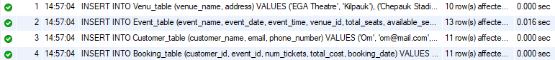

### Write a SQL query to list all Event:

SELECT * FROM event_table;

##### Results:

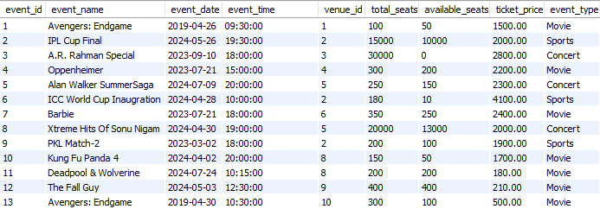

### Write a SQL query to select Event with available tickets:

SELECT * FROM event_table

WHERE available_seats > 0;

##### Results:

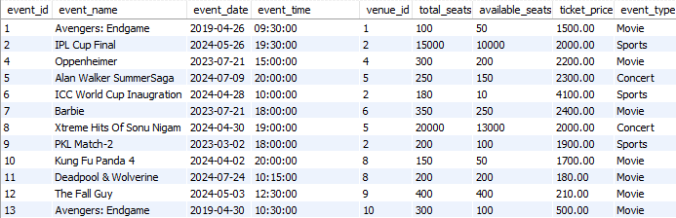

### Write a SQL query to select Event name partial match with ‘cup’:

SELECT * FROM event_table

WHERE event_name LIKE '%cup%';

##### Results:



### Write a SQL query to select Event with ticket price range is between 1000 to 2500:

SELECT * FROM event_table

WHERE ticket_price BETWEEN 1000 AND 2500;

##### Results:

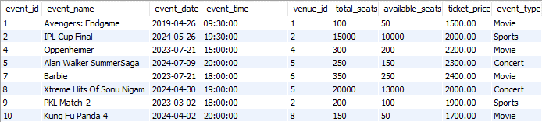

### Write a SQL query to retrieve Event with dates falling within a specific range:

SELECT * FROM event_table

WHERE event_date BETWEEN '2023-07-01' AND '2023-07-30';

##### Results:



### Write a SQL query to retrieve Event with available tickets that also have "Concert" in their name:

SELECT * FROM event_table

WHERE event_type = 'Concert'

AND available_seats > 0;

##### Results:



### Write a SQL query to retrieve users in batches of 5, starting from the 6th user:

SELECT * FROM customer_table

LIMIT 5 OFFSET 5;

##### Results:

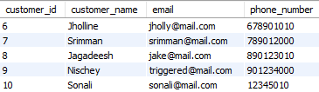

### Write a SQL query to retrieve bookings details contains booked no of ticket more than 4:

SELECT * FROM booking_table

WHERE num_tickets > 4;

##### Results:



### Write a SQL query to retrieve customer information whose phone number end with ‘000’:

SELECT * FROM customer_table

WHERE phone_number LIKE '%000';

##### Results:

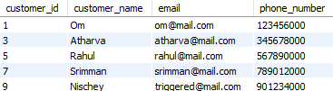

### Write a SQL query to retrieve the Event in order whose seat capacity more than 15000:

SELECT * FROM event_table

WHERE total_seats > 15000

ORDER BY total_seats;

##### Results:



### Write a SQL query to select Event name not start with ‘x’, ‘y’, ‘z’:

SELECT * FROM event_table

WHERE event_name NOT LIKE 'x%'

AND event_name NOT LIKE 'y%'

AND event_name NOT LIKE 'z%';

##### Results:

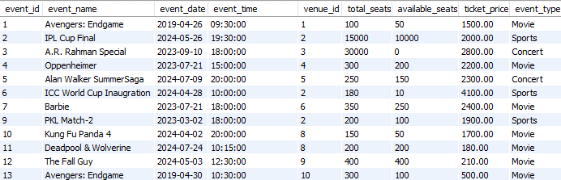

## Tasks 3: Aggregate functions, Having, Order By, GroupBy and Joins:

### Write a SQL query to List Events and Their Average Ticket Prices:

SELECT DISTINCT event_name AS 'List Of Events', AVG(ticket_price) AS 'Average Ticket Price'

FROM event_table

GROUP BY event_name;

##### Results:

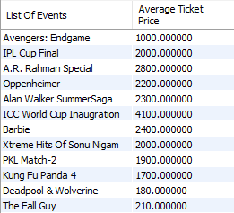

### Write a SQL query to Calculate the Total Revenue Generated by Events:

SELECT event_name AS 'Events', (total_seats*ticket_price) AS 'Total Revenue'

FROM event_table;

##### Results:

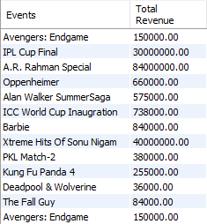

### Write a SQL query to find the event with the highest ticket sales:

SELECT event_name AS 'Events', (total_seats - available_seats) AS 'Tickets Sold'

FROM event_table

WHERE (total_seats - available_seats) = (SELECT

MAX(total_seats - available_seats)

FROM event_table);

##### Results:



### Write a SQL query to Calculate the Total Number of Tickets Sold for Each Event:

SELECT event_name AS 'Events', (total_seats - available_seats) AS 'Tickets Sold'

FROM event_table;

##### Results:

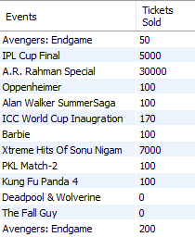

### Write a SQL query to Find Events with No Ticket Sales:

SELECT event_name AS 'Events', (total_seats - available_seats) AS 'Tickets Sold'

FROM event_table

WHERE total_seats = available_seats;

##### Results:

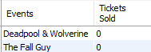

### Write a SQL query to Find the User Who Has Booked the Most Tickets:

SELECT customer_table.customer_name AS Customer, booking_table.num_tickets AS Tickets

FROM customer_table

LEFT JOIN booking_table

ON customer_table.customer_id = booking_table.customer_id

WHERE booking_table.num_tickets = (SELECT

MAX(num_tickets)

FROM booking_table);

##### Results:



### Write a SQL query to List Events and the total number of tickets sold for each month:

SELECT event_name, MONTH(event_date) AS Month, SUM(total_seats - available_seats) AS 'Total Ticket Sales'

FROM event_table

GROUP BY event_name, Month

ORDER BY Month;

##### Results:

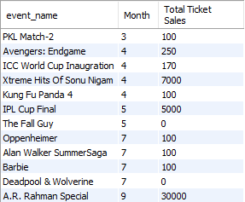

### Write a SQL query to calculate the average Ticket Price for Events in Each Venue:

SELECT v.venue_name AS Venues, AVG(e.ticket_price) AS Average_ticket_price

FROM event_table AS e

RIGHT JOIN venu_table AS v

ON e.venue_id = v.venue_id

GROUP BY v.venue_name;

##### Results:

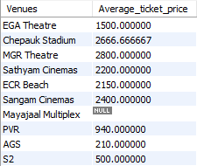

### Write a SQL query to calculate the total Number of Tickets Sold for Each Event Type:

SELECT event_type AS Type_of_Event, SUM(total_seats - available_seats) AS Total_Ticket_Sales

FROM event_table

GROUP BY event_type

ORDER BY Total_Ticket_Sales;

##### Results:

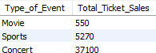

### Write a SQL query to calculate the total Revenue Generated by Events in Each Year:

SELECT YEAR(event_date) AS Year, SUM((total_seats - available_seats)*ticket_price) AS 'Total Revenue'

FROM event_table

WHERE available_seats <> 0

GROUP BY Year

ORDER BY Year;

##### Results:

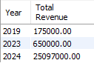

### Write a SQL query to list users who have booked tickets for multiple events:

SELECT c.customer_name AS User, COUNT(b.customer_id) AS Number_of_Bookings

FROM booking_table AS b

RIGHT JOIN customer_table AS c

ON b.customer_id = c.customer_id

GROUP BY c.customer_name

HAVING (Number_of_Bookings > 1);

##### Results:



### Write a SQL query to calculate the Total Revenue Generated by Events for Each User:

SELECT c.customer_name, SUM(b.num_tickets*e.ticket_price) AS Total_Revenue

FROM ((event_table AS e

INNER JOIN booking_table AS b ON e.event_id = b.event_id)

INNER JOIN customer_table AS c ON b.customer_id = c.customer_id)

GROUP BY c.customer_name

ORDER BY Total_Revenue;

##### Results:

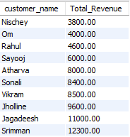

### Write a SQL query to calculate the Average Ticket Price for Events in Each Category and Venue:

SELECT e.event_type, v.venue_name AS Venues, AVG(e.ticket_price) AS Average_ticket_price

FROM event_table AS e

RIGHT JOIN venu_table AS v

ON e.venue_id = v.venue_id

GROUP BY Venues, e.event_type;

##### Results:

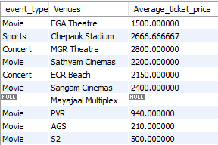

### 14. Write a SQL query to list Users and the Total Number of Tickets They've Purchased in the Last 30 Days:

SELECT customer_name AS Users, COUNT(customer_name) AS Number_of_Bookings

FROM customer_table AS c

JOIN booking_table AS b ON b.customer_id = c.customer_id

WHERE b.booking_date BETWEEN DATE_SUB(CURDATE(), INTERVAL 30 DAY) AND CURDATE()

GROUP BY Users

ORDER BY Number_of_Bookings DESC;

##### Results:

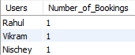

## Tasks 4: Subquery and its types:

### Calculate the Average Ticket Price for Events in Each Venue Using a Subquery:

SELECT venue_name,

(SELECT AVG(ticket_price)

FROM event_table

WHERE venue_id = v.venue_id) AS Average_ticket_price

FROM venu_table AS v

ORDER BY venue_name;

##### Results:

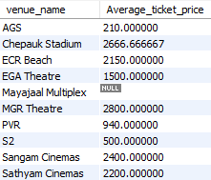

### Find Events with More Than 50% of Tickets Sold using subquery:

SELECT DISTINCT a.event_name AS Events, ((1 - (available_seats / total_seats)) * 100) AS Percent_Sold

FROM event_table AS a

WHERE (SELECT ((1 - (available_seats / total_seats)) * 100)

FROM event_table AS b

WHERE b.event_id = a.event_id) > 50;

##### Results:

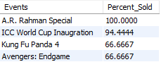

### Calculate the Total Number of Tickets Sold for Each Event:

SELECT event_name,

(SELECT num_tickets

FROM Booking_table

WHERE event_id = e.event_id)

AS Total_Tickets_Sold

FROM Event_table AS e;

##### Results:

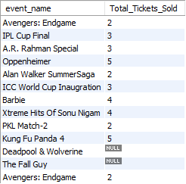

### Find Users Who Have Not Booked Any Tickets Using a NOT EXISTS Subquery:

SELECT customer_name

FROM customer_table AS c

WHERE NOT EXISTS

(SELECT b.customer_id

FROM booking_table

WHERE customer_id = c.customer_id);

##### Results:



### List Events with No Ticket Sales Using a NOT IN Subquery:

SELECT event_name

FROM event_table

WHERE event_name

NOT IN (SELECT event_name

FROM event_table

WHERE total_seats <> available_seats);

##### Results:



### Calculate the Total Number of Tickets Sold for Each Event Type Using a Subquery in the FROM Clause:

SELECT Total_tickets_sold, event_type

FROM (SELECT SUM(b.num_tickets) AS Total_tickets_sold, event_type

FROM event_table AS e

JOIN booking_table AS b

ON e.event_id = b.event_id

GROUP BY event_type) AS ticket_sales;

##### Results:

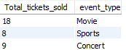

### Find Events with Ticket Prices Higher Than the Average Ticket Price Using a Subquery in the WHERE Clause:

SELECT event_name, ticket_price

FROM event_table

WHERE (SELECT AVG(ticket_price)

FROM event_table) < ticket_price;

##### Results:

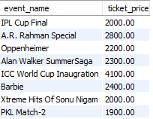

### Calculate the Total Revenue Generated by Events for Each User Using a Correlated Subquery:

SELECT customer_name,

(SELECT SUM(total_cost)

FROM booking_table

WHERE customer_id = c.customer_id

GROUP BY customer_id) AS Total_Revenue

FROM customer_table AS c;

##### Results:

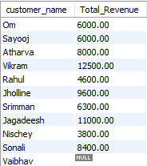

### List Users Who Have Booked Tickets for Events in a Given Venue Using a Subquery in the WHERE Clause:

SELECT c.customer_name

FROM Customer_table AS c

JOIN Booking_table AS b ON c.customer_id = b.customer_id

JOIN Event_table AS e ON b.event_id = e.event_id

WHERE e.venue_id = (SELECT venue_id

FROM Venu_table

WHERE venue_name = 'EGA Theatre');

##### Results:



### Calculate the Total Number of Tickets Sold for Each Event Category Using a Subquery with GROUP BY:

SELECT Total_tickets_sold, event_type

FROM (SELECT

SUM((total_seats-available_seats)*ticket_price) AS Total_tickets_sold, event_type

FROM event_table

GROUP BY event_type) AS ticket_sales;

##### Results:

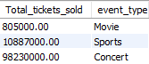

### Find Users Who Have Booked Tickets for Events in each Month Using a Subquery with DATE_FORMAT:

SELECT customer_name,

(SELECT DATE_FORMAT(booking_date,"%b")

FROM booking_table

WHERE customer_id = c.customer_id

GROUP BY booking_date) AS Booking_month

FROM customer_table AS c;

##### Results:

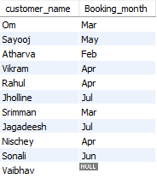

### Calculate the Average Ticket Price for Events in Each Venue Using a Subquery:

SELECT (SELECT venue_name

FROM venu_table

WHERE venue_id = e.venue_id) AS venue,

AVG(ticket_price)

FROM event_table AS e

GROUP BY venue;

##### Results:

